**NAME** :- Manish Shashikant Jadhav

**UID** :- 2023301005.

**BRANCH** :- Comps -B. **BATCH:** B.

**EXPERIMENT 3:** To perform DCL, TCL commands

* Data Control Language: Grant, Revoke, Roles.
* Transaction Control Language: Commit, Rollback, Save point

**SUBJECT** :- DBMS (DATABASE MANAGEMENT SYSTEM)

**TOPIC NO.1: DDL Commands:**

1. **Create user by your name by using create user command:**

create user 'Manish'@'localhost' identified by '2809';

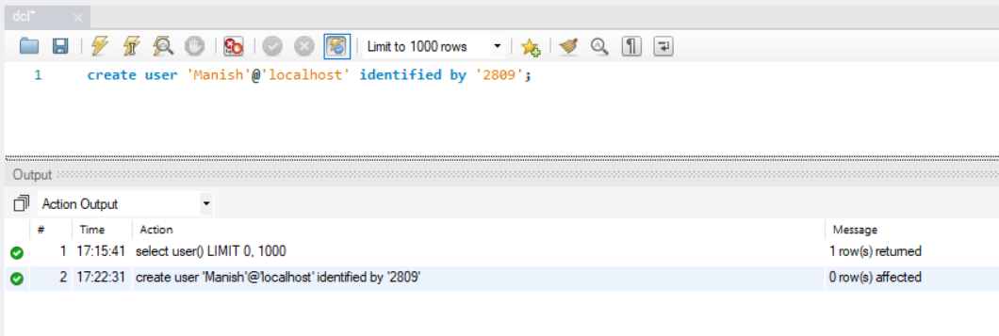

1. **Show the default permission for user:**

show grants for 'Manish'@'localhost';

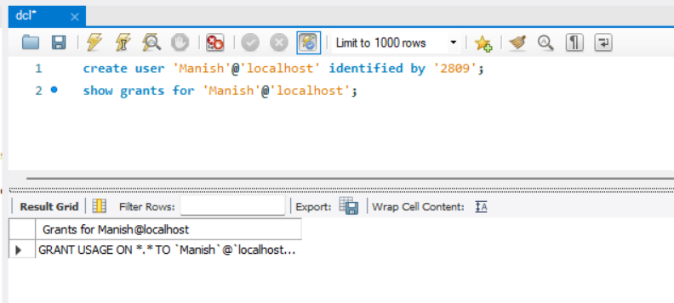

1. **Create a database and one table in it/use created database and tables:**

create database exp3;

use exp3;

create table office(id int primary key, name varchar(20));



1. **Give select permission to new user to created table:**

grant select on *.* to 'Manish'@'localhost';

show grants for 'Manish'@'localhost';

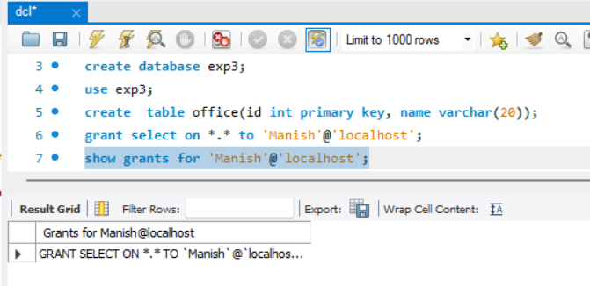

1. **Try to insert value in table note the result:**

insert into office (id, name) values (1, 'Manish');



1. **Give the insert permission to new user :**

grant insert on *.* to 'Manish'@'localhost';

show grants for 'Manish'@'localhost';

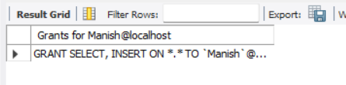

1. **Insert some value in the table:**

insert into office (id, name) values (1, 'Manish');

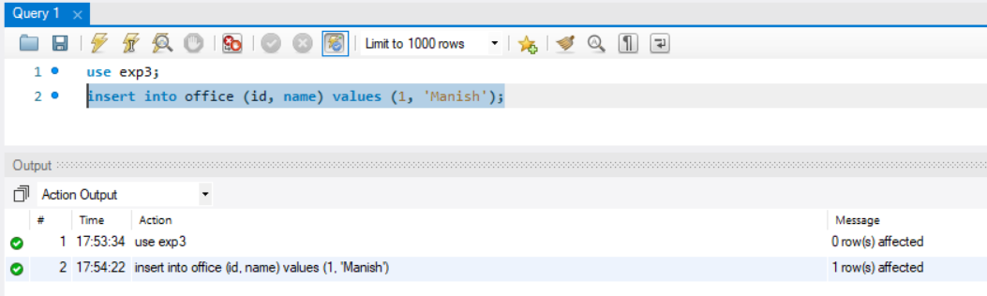

1. **Display the table:**

select * from office;

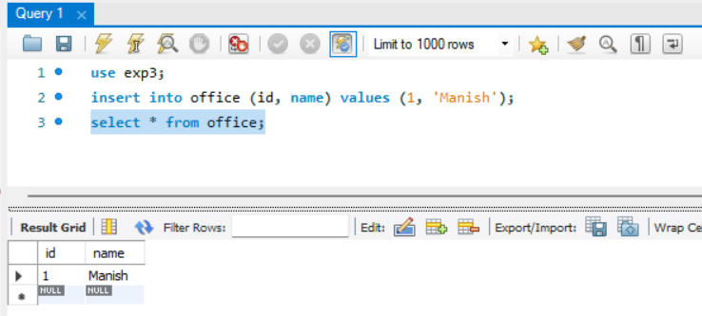

1. **Update the table and note down the result:**

update office set name='Nishant' where id=1;



1. **Give the update permission to the user:**

grant update on *.* to 'Manish'@'localhost';

show grants for 'Manish'@'localhost';

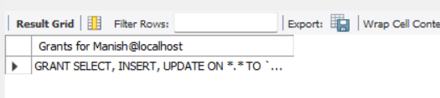

* **After Giving Update Permission:**

update office set name='Nishant' where id=1;

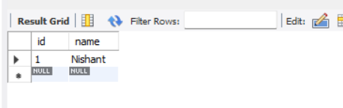

1. **Give all permission to user:**

grant all on *.* to 'Manish'@'localhost';

show grants for 'Manish'@'localhost';

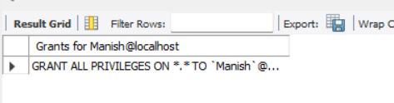

1. **Revoke update permission from   and try to update the table:**

revoke update on *.* from 'Manish'@'localhost';

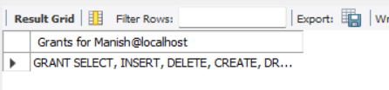

update office set name=‘Krunal’ where id=1;



1. **Create the role:**

create role 'accountant';



1. **Give select privileges to new role:**

grant select on office to accountant;

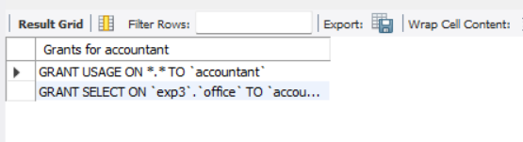

1. **Create new user:**

create user 'Nishant'@'localhost' identified by '2810';



1. **Give the role to new user.**

create role 'financer';

grant 'financer' to 'Nishant'@'localhost';

show grants for 'Nishant'@'localhost';

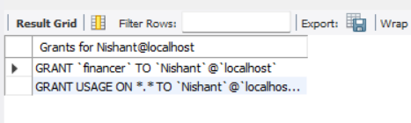

**TOPIC NO.2: TCL Commands:**

1. **Display the table you have created:**

select * from data;

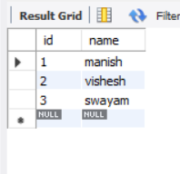

1. **Perform some insert , update and delete operation on table:**

insert into data (id, name) values (4, 'jay') , (5, 'apurva'), (6, 'shrijal');

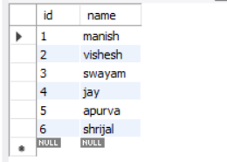

update data set name = 'richa' where id = 4;

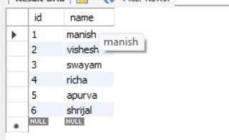

delete from data where id=4;

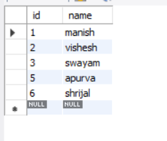

insert into data (id, name) values (7, 'x') , (8, 'y'), (9, 'z');

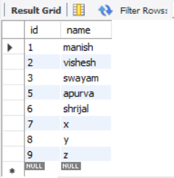

1. **Display the table:**



1. **Use rollback command &**
2. **Display the table and write your observation:** rollback;

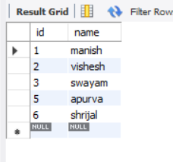

1. **Insert one row in the table:**

insert into data (id, name) values (7, 'x');

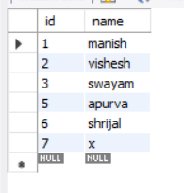

1. **Use commit command:**



1. **Insert one more row :**

insert into data (id, name) values (8, 'y');

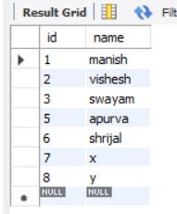

1. **Use rollback command and observe the output:** rollback;

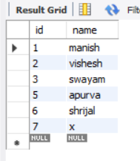

We were returned to output where last commit was declared.

1. **Update the table and again use the rollback command:**

update data set name = 'z' where id = 7;

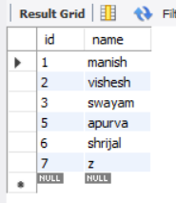

rollback;

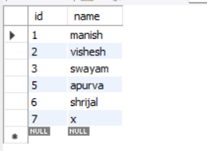

1. **Delete one row and use rollback command:**

delete from data where id=7;

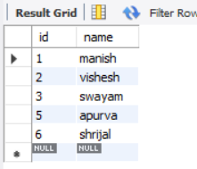

rollback;

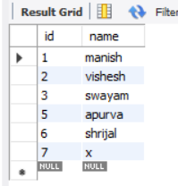

1. **Create savepoint:**



1. **Perform one insertion , deletion and update operation:**

insert into data (id, name) values (10, 'mj');

update data set name = 'aj' where id = 10;

delete from data where id=6;

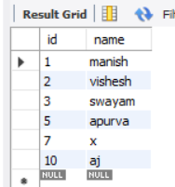

1. **Use rollback command:**

rollback to savepoint m;

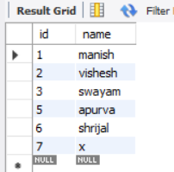

1. **Perform update operation :**

update data set name = 'aj' where id = 5;

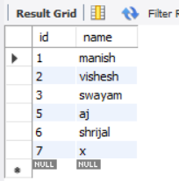

1. **Use rollback and observe the output:**

rollback;

